**Q.1)Find the output of the given Java program?**

public class Main {

public static void main(String args[]) {

System.out.println("Hello World");

}

} 1. Hello World

2. HelloWorld

3. Compiled Successfully, No Output.

4. Compile-time error

Answer:1. Hello World

Q.2)**Find the output of the given program?**

class Test{

public static void main(String[] args) {

int out=9;

System.out.print(out+" ");

println();

}

public static void println(){

System.out.println("Hi");

}

}

1. 9

2. 9 Hi

3. Compile-time error

4. Exception

Answer:2. 9 Hi

**Q.3)Find the output of the given program?**

class Test{

public static void main(String[] args) {

String String = "String";

System.out.println(String);

}

}

1. String

2. Compile-time error

3. Exception

4. None of these

Answer:1. String

**Q.4)Find the output of the below Java program?**

class Test{

public static void main(String[] args) {

char ch1 = 97;

char ch2 = -98;

System.out.println(ch1+".."+ch2);

}

}

1. 97..98

2. a..b

3. a..-b

4. None of these

Answer:4. None of these

**Q.5)What is the output of the Java code snippet?**

int a=5, b=10, c=15;

a -= 3;

b *= 2;

c /= 5;

System.out.println(a +" " + b + " " + c);

1. 2 20 3

2. 2 20 5

3. 2 10 5

4. -2 20 3

Answer:1. 2 20 3

**Q.6)Find the output of the given Java program?**

public class Main

{

public static void main(String[] args) {

if(1>3)

System.out.println("Know Program");

}

}

1. Know Program

2. Other Output

3. Compiled Successfully, No Output.

4. Compile-time error

Answer:3. Compiled Successfully, No Output

Q.7)**Find the output of the given Java program?**

public class Main

{

public static void main(String[] args) {

if(5<4)

System.out.println("Hi");

else

System.out.println("Hello");

}

}

1. Hi

2. Hello

3. Compiled Successfully, No Output.

4. Compile-time error

Answer:2. Hello

**Q.8)Find the output of the given Java program?**

public class Main

{

public static void main(String[] args) {

boolean x, y, z;

x = y = z = true;

if(!x || (!y && !z))

System.out.println("Hi");

else

System.out.println("Hello");

}

}

1. Hi

2. Hello

3. Compiled Successfully, No Output.

4. Compile-time error

Answer:2. Hello

**Q.9)What is the correct output of this program ?**

public class ControlStatement {

public static void main(String[] args) {

String a = "JavaFx";

switch(a){

case "C":

case "C++":

System.out.print("Basic Subjects");

break;

case "Java":

case "JavaScript":

case "JavaFx":

System.out.print("Java Subjects");

break;

1. Basic Subjects

2. Java Subjects

3. Microsoft Subjects

4. Default

Answer: 2. Java Subjects

**Q.10)What is the output of the following code?**

public class LoopExample {

public static void main(String[] args) {

int i = 0;

while (i < 3) {

System.out.print(i + " ");

i++;

}

}

}

1. 0 1 2

2. 0 1 2 3

3. 1 2 3

4. 0 1 2 3

Answer:1. 0 1 2

**Q.11)What will be the output of the following code?**

public class LoopOutput {

public static void main(String[] args) {

int sum = 0;

for (int i = 1; i <= 5; i++) {

sum += i;

}

System.out.print(sum);

}

}

1. 5

2. 10

3. 15

4. 20

Answer:15

**Q.12)What will be the output of the following Java code?**

class array_output

{

public static void main(String args[])

{

int array_variable [] = new int[10];

for (int i = 0; i < 10; ++i)

{

array_variable[i] = i;

System.out.print(array_variable[i] + " ");

i++;

}

}

}

1. 0 2 4 6 8

2. 1 3 5 7 9

3. 0 1 2 3 4 5 6 7 8 9

4. 1 2 3 4 5 6 7 8 9 10

Answer:1. 0 2 4 6 8

**Q.13)What will be the output of the following Java code snippet?**

Object[] names = new String[3];

names[0] = new Integer(0);

1. ArrayIndexOutOfBoundsException

2. ArrayStoreException

3. Compilation Error

4. Code runs successfully

Answer:2. ArrayStoreException

**Q.14)While mentioning the array size in a multidimensional array using the new keyword, the left-most script is mandatory. State TRUE or FALSE.**

int ary[][];

ary = new int[5][];//first dimension is compulsory.

1. FALSE

2. TRUE

Answer:2. True

**Q.15)What is the output of the Java program with the multidimensional array?**

int[][] goats;

goats = new int[3][];

goats[0] = {1,2};

System.out.println(goats[0][1]);

1. 0

2. 1

3. 2

4. Compiler error

Answer:4. Compile error

**Q.16)Choose the correct way of initializing a multidimensional array below.**

1. int[][] code = {{1,2},{3,4,5}};

2. int[2][] code = {{1,2},{3,4,5}};

3. int[][] code={1,2, 3,4,5};

4. All

**Answer:1. int[][] code = {{1,2}, {3,4,5}};**

**Q.17)What will be the output of the following Java code?**

class array_output

{

public static void main(String args[])

{

int array_variable[][] = {{ 1, 2, 3}, { 4 , 5, 6}, { 7, 8, 9}};

int sum = 0;

for (int i = 0; i < 3; ++i)

for (int j = 0; j < 2 ; ++j)

sum = sum + array_variable[i][j];

System.out.print(sum);

}

}

1. 12

2. 27

3. 21

4. 45

Answer 12

**Q.18)Find the output of the below Java program?**

public class Test {

public static void main(String[] args) {

Test t1 = new Test();

Test t2 = new Test();

System.out.println(t1.equals(t2));

}

}

1. true

2. false

3. null

4. Error

Answer: false

**Q.19)Choose the correct way of creating an object of the below class**

class Table

{

Table(){System.out.println("Table Created");}

}

1. Table t = new Table;

2. Table t = new Table();

3. Table() t = new Table();

4. None of the above

Answer:2. Table t = new Table();

**Q.20)Predict the output of following Java program?**

class Test { int i; } class Main { public static void main(String args[]) { Test t; System.out.println(t.i); }

1. 0

2. garbage value

3. compiler error

4. runtime error

Answer: compiler error

**Q.21) Find the output of the below Java program?**

class Student {

public class Test {

public static void main(String[] args) {

Student s1 = new Student();

System.out.println(s1.getClass().getName());

}

}

1. Test

2. Student

3. Object

4. Class

Answer:. Student

**Q.22)What is the output of the below Java program using Inheritance?**

class Furniture

{

void show()

{

System.out.println("Made of Wood. ");

}

}

class Sofa extends Furniture

{

void addCushion()

{

System.out.println("Added. ");

}

}

public class Inheritance6

{

public static void main(String[] args)

{

Furniture fur = new Sofa();

fur.addCushion();

}}

1. Added.

2. No output

3. Added. Made of Wood.

4. Compiler error

ANswer: Compiler error

**Q.23)What will be the output of the following Java code?**

class A {

public int i;

public int j;

A() {

i = 1;

j = 2;

}

}

class B extends A {

int i;

B() {

super();

i = 3;

}

}

class super_use {

public static void main(String args[]) {

B obj = new B();

System.out.println(obj.i + " " + obj.j);

}

}

1. 1 2

2. 3

3. 3 2

4. Runtime Error

Answer:3. 3 2

**Q.24)What is the output of the below Java program with an abstract class?**

abstract class MathLibrary

{

static final float PI = 3.1415f;

}

public class AbstractClassTesting3

{

public static void main(String[] args)

{

System.out.println(MathLibrary.PI);

}

}

1. 3.1415

2. No Output

3. Error

4. None of the above

Answer: 3.1415

**Q.25)What will be the output of the following Java program?**

class String_demo

{

public static void main(String args[])

{

int ascii[] = { 65, 66, 67, 68};

String s = new String(ascii, 1, 3);

System.out.println(s);

}

}

1. ABC

2. BCD

3. CDA

4. ABCD

Answer:2. **BCD**

**Q.26)What will be the output of the following Java code?**

class output

{

public static void main(String args[])

{

String a = "hello i love java";

System.out.println(a.indexOf('i')+" "+a.indexOf('o') +" "+a.lastIndexOf('i')+" "+a.lastIndexOf('o'));

}

}

1. 6 4 6 9

2. 5 4 5 9

3. 7 8 8 9

4. 4 3 6 9

Answer:1. 6 4 6 9

**Q.27)What will be output of the following code?**

public class Boxer1

{

Integer i;

int x;

public Boxer1(int y)

{

x = i+y;

System.out.println(x);

}

public static void main(String[] args)

{

new Boxer1 (new Integer(4));

}

}

1. The value '4' is printed at the command line

2. Compilation fails because of an error in line

3. A NullPointerException occurs at runtime

4. An IllegalStateException occurs at runtime

Answer:4. An IllegalStateException occurs at runtime

**Q.28)Consider the given code:**

class String_demo

{

public static void main(String args[])

{

char arr[] = {'Q','W','E','R','T','Y};

}

}

Which among the following option will print QWERTY

1. System.out.println(arr);

2. System.out.println(arr.toString());

3. new String(arr); System.out.println(str);

4. System.out.println(Arrays.toString(arr));

Answer:3. new String(arr); System.out.println(str);

**Q.29)What is the output of the Java code with custom exceptions?**

public class ExceptionTest15

{

void show(int a) throws MyException

{

System.out.println("Hello Custom Exception");

int b = a/0;

}

public static void main(String[] args)

{

ExceptionTest15 obj = new ExceptionTest15();

obj.show(5);

System.out.println("Bye Custom Exception");

}

}

class MyException extends Exception

{

MyException(){ super();}

MyException(String name){ super(name); }

}

1. Hello Custom Exception Bye Custom Exception

2. Hello Custom Exception

3. Bye Custom Exception

4. Compiler error

Answer:2. Hello Custom Exception

**Q.30)What will be the output of the program?**

import java.util.*;

class H

{

public static void main (String[] args)

{

Object x = new Vector().elements();

System.out.print((x instanceof Enumeration)+",");

System.out.print((x instanceof Iterator)+",");

System.out.print(x instanceof ListIterator);

}

}

1. Prints: false,false,false

2. Prints: false,false,true

3. Prints: false,true,false

4. Prints: true,false,false

Answer:4. Prints: true, false, false

**Q.31)What will be the output of the program?**

TreeSet map = new TreeSet();

map.add("one");

map.add("two");

map.add("three");

map.add("four");

map.add("one");

Iterator it = map.iterator();

while (it.hasNext() )

{

System.out.print( it.next() + " " );

}

1. one two three four

2. four three two one

3. four one three two

4. one two three four one

Answer:1. one two three four

**Q.32)What will be the output of the below program?**

class MyThread extends Thread {

public void run() {

System.out.print("run() ");

}

}

public class ThreadDemo {

public static void main(String[] args) {

MyThread t = new MyThread();

System.out.print("main() ");

t.run();

}

}

1. run() main()

2. main() run()

3. Sometimes (a) and Sometimes (b)

4. None of these.

Answer:2. main() run()

**Q.33)Find the output of the below program?**

class MyThread extends Thread {

}

public class ThreadDemo {

public static void main(String[] args) {

MyThread t = new MyThread();

t.start();

}

}

1. Compile time error

2. Run time error

3. No output

4. None of these

Answer: No output

**Q.34)What is the possible output of the below program?**

class MyThread extends Thread {

public void start() {

System.out.print("start() Method, ");

}

public void run() {

System.out.print("run() Method, ");

}

}

public class ThreadDemo {

public static void main(String[] args) {

MyThread t = new MyThread();

t.start();

System.out.println("Main Thread, ");

}

}

1. Main Thread, start() method,

2. Main Thread, run() method,

3. run() method, Main Thread,

4. start() method, Main Thread,

Answer:4. start() method, Main Thread

**Q.35)A new thread will be created or not, what will be the output of the below program?**

class MyRunnable implements Runnable {

public void run() {

System.out.println("Child thread");

}

}

public class Test {

public static void main(String[] args) {

MyRunnable r = new MyRunnable();

Thread t1 = new Thread();

Thread t2 = new Thread(r);

t2.run();

}

}

1. No; Child thread

2. Yes; Child thread

3. No; No Output

4. Yes; No Output

Answer:1. No; Child thread

**Q.36)Given the following code, what will be the output?**

interface MyInterface {

int operate(int x, int y);

}

public class LambdaTest {

public static void main(String[] args) {

MyInterface add = (a, b) -> a + b;

System.out.println(add.operate(5, 3));

}

}

1. 8

2. 53

3. Compilation error

4. No output

Answer:8

**Q.37)Given the following code, what will be the output?**

List names = Arrays.asList("Alice", "Bob", "Charlie");

names.forEach(name -> System.out.print(name + " "));

1. Alice Bob Charlie

2. AliceBobCharlie

3. Compile-time error

4. Runtime exception

Answer:1. Alice Bob Charlie

**Q.38)What is the output of the following code snippet?**

List numbers = Arrays.asList(1, 2, 3, 4);

numbers.forEach(n -> { if (n % 2 == 0) { System.out.print(n + " "); } });

1. 1 2 3 4

2. 2 4

3. 1 3

4. 4 2

Answer:2. 2 4

**Q.39)Which of the following is a valid forEach() statement to print only non-null elements from a List?**

1. list.forEach(s -> { if (s != null) System.out.println(s); });

2. list.forEach(s -> System.out.println(s != null));

3. list.forEach(s -> System.out.print(s));

4. list.forEach(() -> s != null);

Answer:1. list.forEach(s -> { if (s != null) System.out.println(s); });

**Q.40)Given the following code, what will be the output?**

class Printer {

static void print(String msg) {

System.out.println(msg);

}

}

public class Test {

public static void main(String[] args) {

List list = Arrays.asList("A", "B", "C");

list.forEach(Printer::print);

}

}

1. A B C

2. A, B, C

3. [A, B, C]

4. Compile-time error

Answer:1. A B C

**Q.41)What will happen if we try to compile and run below program?**

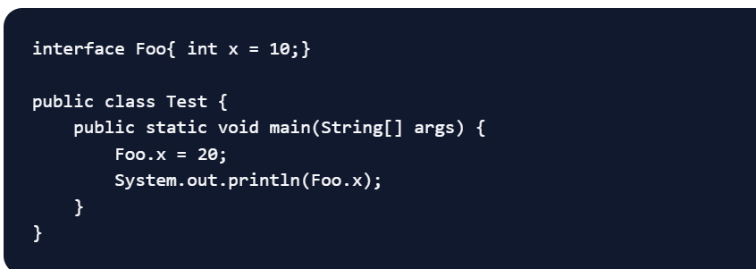

A. Prints 10

B. Prints 20

C. Compile Time Error

D. Runtime error because Foo.x is final.

Answer:C

**Q.42)What will be the output of the below program?**

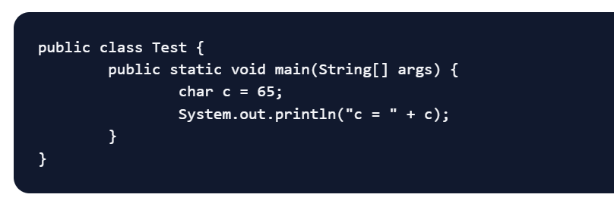

A. Compile Time Error

B. Prints “c = A”

C. Runtime Error

D. Prints “c = 65”

Answer:B

**Q.43)11. What will be the output of below program?**

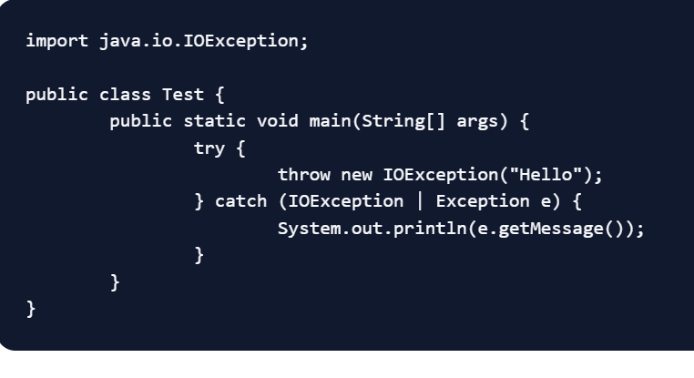

**A. Compile-time error**

**B. Prints “Hello”**

**C. Runtime Error**

**ANswer:A**

**Q.44)What will be the output of below program?**

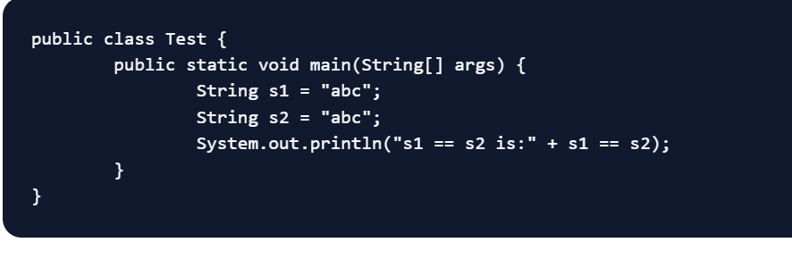

**A. s1 == s2 is:true**

**B. false**

**C. s1 == s2 is:false**

**D. true**

**Answer:**B

Q.45) **What will be the output of below program?**

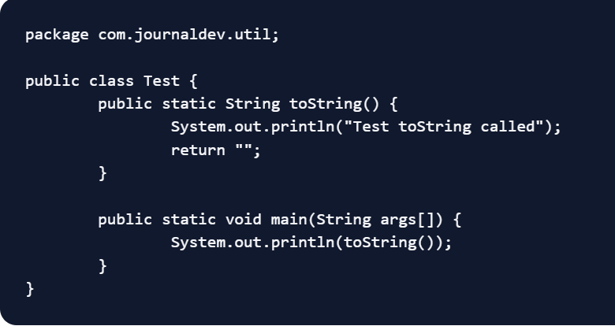

A. “Test toString called”

B. Compile-time error

C. “Test[@7fh2bd8](https://www.digitalocean.com/community/users/7fh2bd8)” (Object class toString() method is being called)

Answer:B

Q.46)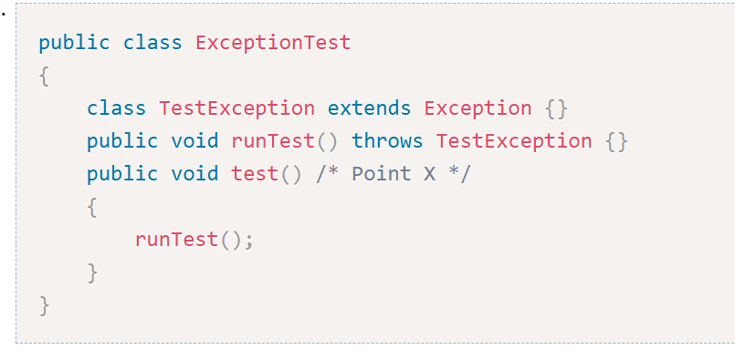

At Point X on line 5, which code is necessary to make the code compile?

1)No code is necessary.

2)throws Exception

3)catch ( Exception e )

4)throws RuntimeException

Answer:2

**Q.47)What will be the output of the program?**

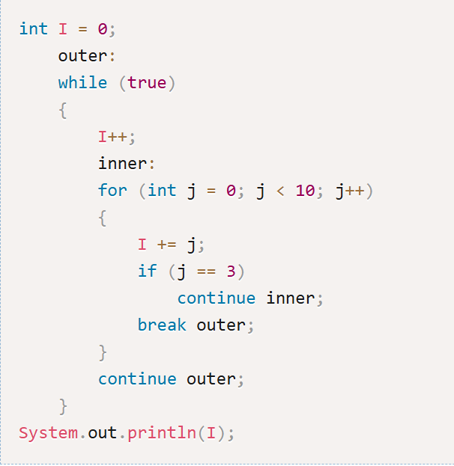

A)1

B)2

C)3

D)4

Answer:A

**Q.48)What will be the output of the program?**

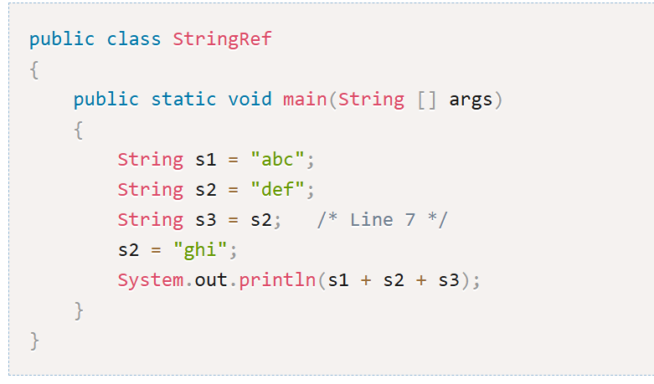

1)abcdefghi

2)abcdefdef

3)abcghidef

4)abcghighi

Answer

3

**Q,49)What will be the output of the program?**

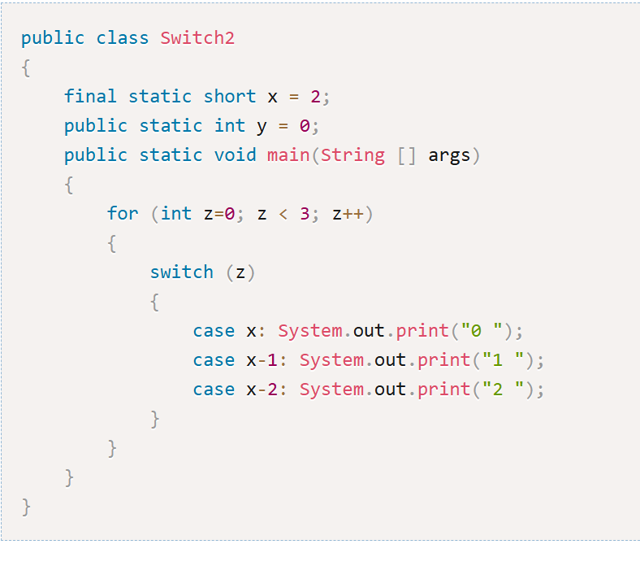

1)0 1 2

2)0 1 2 1 2 2

3)2 1 0 1 0 0

4)2 1 2 0 1 2

Answer:4

**Q.50)What will be the output of the program?**

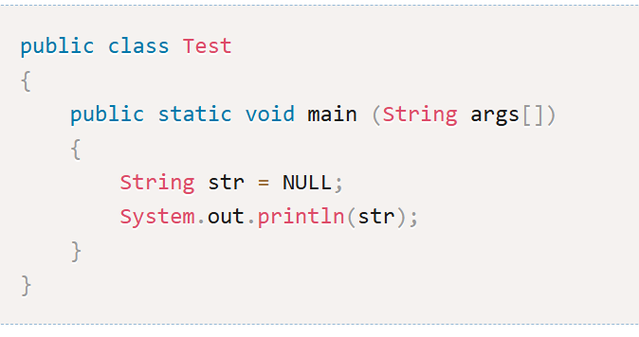

1)NULL

2)Compile Error

3)Code runs but no output

4)Runtime Exception

Answer:2